Class Design - Controller

# Create Initial Design Classes

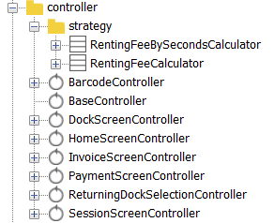

# Define Relationships Between Classes

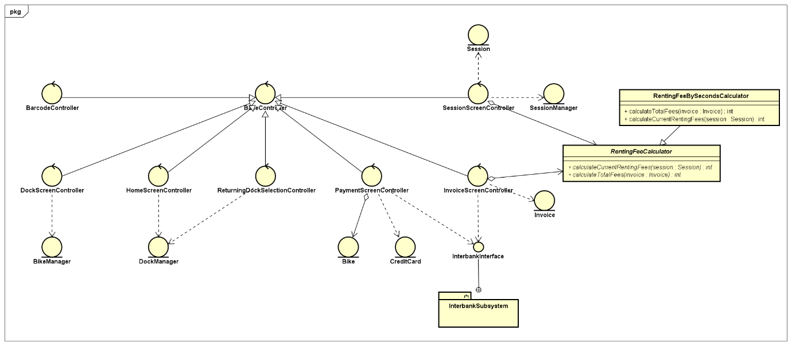

# Class Design

## Class “BaseController”

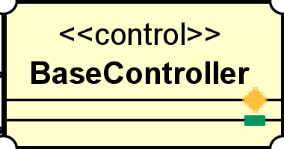

**Attribute**

None

**Operation**

None

Parameter:

None

Exception:

None

**Method**

None

**State**

None

## Class “BarcodeController”

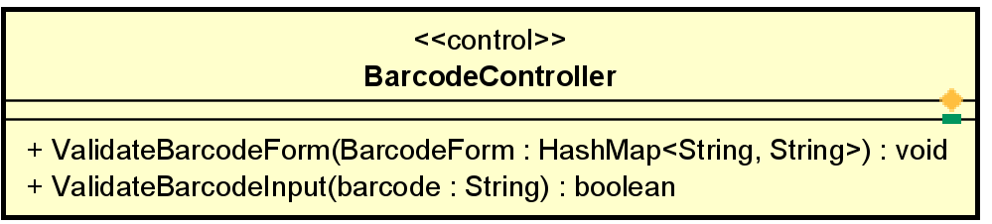

**Attribute**

None

**Operation**

|  |  |  |  |
| --- | --- | --- | --- |
| # | Name | Return type | Desciption |
| 1 | ValidateBarcodeForm | void | Validates barcode form |
| 2 | ValidateBarcodeInput | boolean | Checks if barcode is entered or not |

Parameter:

BarcodeForm – Barcode

Barcode - barcode

Exception:

BarcodeNotFoundException

NullBarcodeException

InvalidBarcodeException

**Method**

None

**State**

None

## Class “DockScreenController”

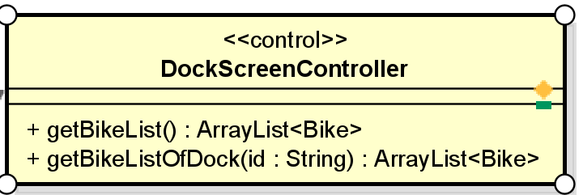

**Attribute**

None

**Operation**

|  |  |  |  |
| --- | --- | --- | --- |
| # | Name | Return type | Desciption |
| 1 | getBikeList | ArrayList | Get bike list |
| 2 | getBikeListOfDock | ArrayList | Get bike list by using dock id |

Parameter:

Id – dock id

Exception:

None

**Method**

None

**State**

None

## Class “HomeScreenController”

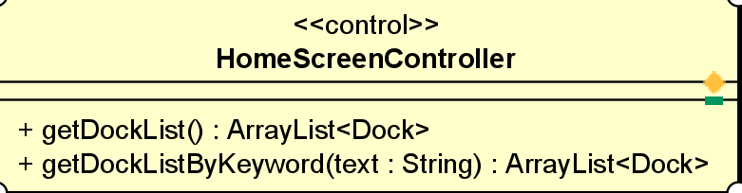

**Attribute**

None

**Operation**

|  |  |  |  |
| --- | --- | --- | --- |
| # | Name | Return type | Desciption |
| 1 | getDockList | ArrayList | Get dock list |
| 2 | getDockListByKeyword | ArrayList | Get dock list by keyword |

Parameter:

Text - keyword

Exception:

None

**Method**

None

**State**

None

## Class “InvoiceScreenController”

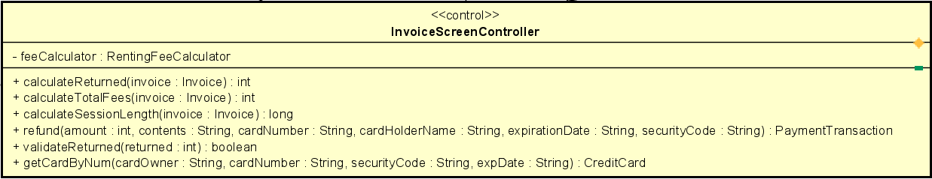

**Attribute**

|  |  |  |  |  |
| --- | --- | --- | --- | --- |
| # | Name | Data type | Default value | Description |
| 1 | feeCalculator | RentingFeeCalculator | new RentingFeeBySecondsCalculator | calculate fee |

**Operation**

|  |  |  |  |
| --- | --- | --- | --- |
| # | Name | Return type | Desciption |
| 1 | calculateReturned | Int | Calculate returned after deducting renting fees |
| 2 | calculateTotalFees | Int | Calculate total fees |
| 3 | calculateSessionLength | long | Session length |
| 4 | refund | PaymentTransaction | Create return transaction |
| 5 | validateReturned | boolean | Check returned validity |
| 6 | getCardByNum | CreditCard | Get creditcard info |

Parameter:

Invoice

Amount

Contents

CardNumber

CardOwner

ExpirationDate

SecurityCode

Returned

Exception:

PaymentException

NullCardNumberException

NullCardOwnerException

NullExpDateException

NullSecurityCodeException

CardExpiredException

**Method**

None

**State**

None

## Class “PaymentScreenController”

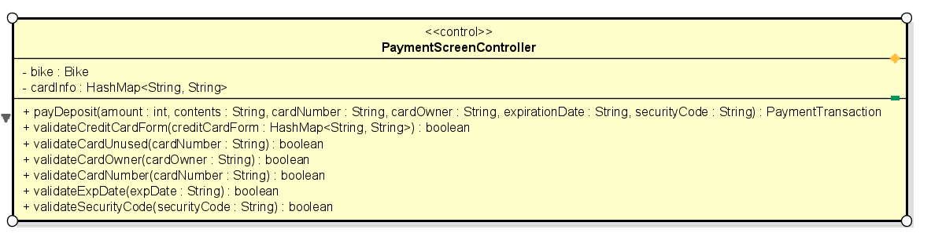

**Attribute**

|  |  |  |  |  |
| --- | --- | --- | --- | --- |
| # | Name | Data type | Default value | Description |
| 1 | bike | Bike | NULL | bike |
| 2 | cardInfo | HashMap<String, String> | NULL | Card info |

**Operation**

|  |  |  |  |
| --- | --- | --- | --- |
| # | Name | Return type | Desciption |
| 1 | payDeposit | PaymentTransaction | Set rent transaction |
| 2 | validateCreditCardForm | boolean | Check creditcard form |
| 3 | validateCardUnused | boolean | Check creditcard used or not |
| 4 | validateCardNumber | boolean | Check creditcard number |
| 5 | validateCardOwner | boolean | Check creditcard owner |
| 6 | validateExpDate | boolean | Check creditcard exp date |
| 7 | validateSecurituCode | boolean | Check creditcard security code |

Parameter:

Amount

Contents

CardNumber

CardOwner

ExpirationDate

SecurityCode

creditCardForm

Exception:

None

**Method**

None

**State**

None

## Class “ReturningDockSelectionController”

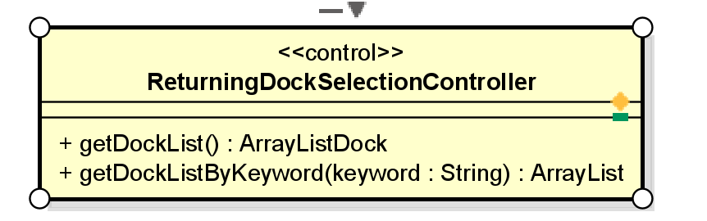

**Attribute**

None

**Operation**

|  |  |  |  |
| --- | --- | --- | --- |
| # | Name | Return type | Desciption |
| 1 | getDockList | ArrayList<Dock> | Get dock list |
| 2 | getDockListByKeyWord | ArrayList<Dock> | Get dock list by keyword |

Parameter:

keyword

Exception:

None

**Method**

None

**State**

None

## Class “SessionScreenController”

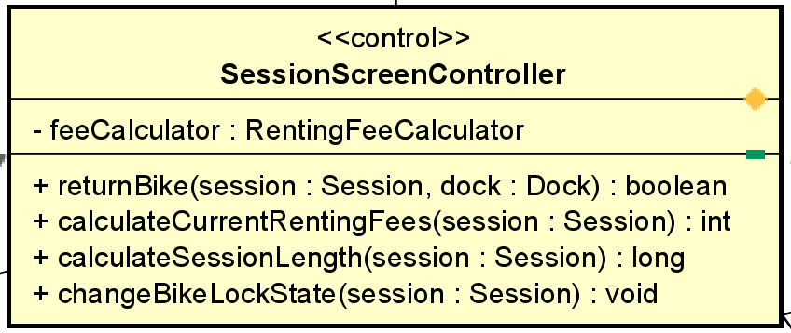

**Attribute**

|  |  |  |  |  |
| --- | --- | --- | --- | --- |
| # | Name | Data type | Default value | Description |
| 1 | feeCalculator | RentingFeeCalculator | new RentingFeeBySecondsCalculator | calculate fee |

**Operation**

|  |  |  |  |
| --- | --- | --- | --- |
| # | Name | Return type | Desciption |
| 1 | returnBike | boolean | Check if bike is available |
| 2 | calculateCurrenRentingFees | int | Calculate current renting fees |
| 3 | calculateSessionLength | long | Calculate session length |
| 4 | changeBikeLockState | void | Change bike lock state |

Parameter:

Session

Dock

Exception:

None

**Method**

None

**State**

None

# Class Diagram

